Cycle route – 26 miles – start Yarnton – Eynsham start take off 7 miles

Appleton Loop

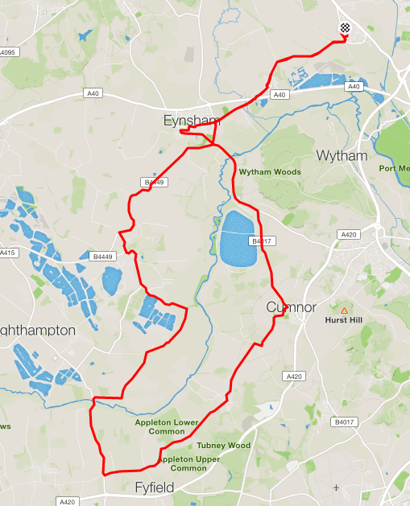

Basic directions

1. Leave Yarnton along Cassington road, at A40 take Old Cassington Road

(mass start is usually the Back Lane car park)

1. Leave Eynsham via the toll Bridge.

At Farmoor, turn right at mini roundabout toward Cumnor.

Up into Cumnor, at the mini roundabout turn right and cycle past the Bear and Ragged Staff towards Appleton

Through Appleton and onward until the main Road.

Turn Right and downhill until the Rose Revived/Maybush bridges.

Immediately after the Rose Revived turn right towards Northmoor

At junction turn Right into Northmoor, onward, past Bablock Hythe. At T junction turn Right towards Stanton Harcourt.

After Stanton Harcourt, turn right at the roundabout for Eynsham.

1. At Eynsham Fire Station Roundabout turn right along the ring road until you can turn right into the Old Cassington Road and reverse the first part of the cycle.