Cycle route – 35/37 miles – start Yarnton – Eynsham start less 2 miles
Leafield Charlbury Loop

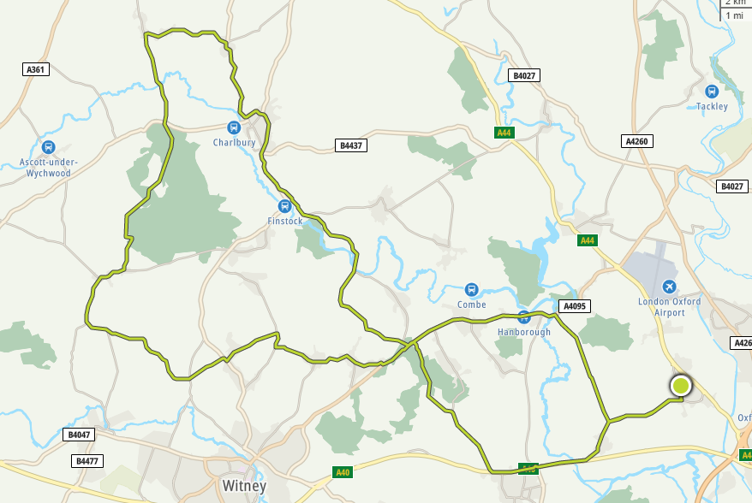

Basic directions
- Leave Yarnton along Cassington road, at A40 take Cycle track or Old Cassington Road if meeting at carpark
(mass start is usually the Back Lane car park)
- Leave Eynsham by A40 traffic lights, cross road.
Turn right toward Freeland., but turn left before Freeland up and turn right onto Cuckoo Lane
At junction turn left and cycle up into North Leigh, turning right into village by Eynsham Hall
Through North Leigh and turn right into New Yatt and onto junction turning right again towards Ramsden.
Shortly turn left, narrow lane, towards Delly End,
On to main road, turn right then left down narrow lane
At Junction turn left and you come out at the top of the hill out of Crawley.
Turn Right along Leafield Road, stay on this road
Take right fork along Riding Lane then a left bend towards Field Assarts before going right uphill into Leafield.
The Junction in Leafield is past the Church a bit, turn left toward Chadlington and the Wychwood Forest
At minor cross road take left then straight over the main road towards Chadlington
At the Junction turn right towards Spelsbury by Postie Café.

C-
Option A – take right turn direct to Charlbury, take first left and cycle around the park to Junction, then straight over to the big downhill……..

Option B Take the left fork in Spelsbury, then straight across the road to Taston
At the junction turn right towards Charlbury (Old Shed Café along here) in Charlbury after initial short hill climb turn left to the big downhill (plus 2-3 Miles?)

You’re now at the same place so down the big hill and up, at the sharp corner take the right fork towards Finstock
Shortly take the first left toward Fawler/Stonesfield
Go through Fawler but take right fork on leaving the village towards North Leigh/West End At the bridge turn right, downhill and back uphill to the Long Hanborough to Witney Road.
Turn Left, down into and through Long Hanborough, turn right into Burley Road towards Cassington, then left on Cassington Road back to Yarnton

