Cycle route – 35 miles – start Yarnton – Eynsham take off 7 miles
Bampton Loop
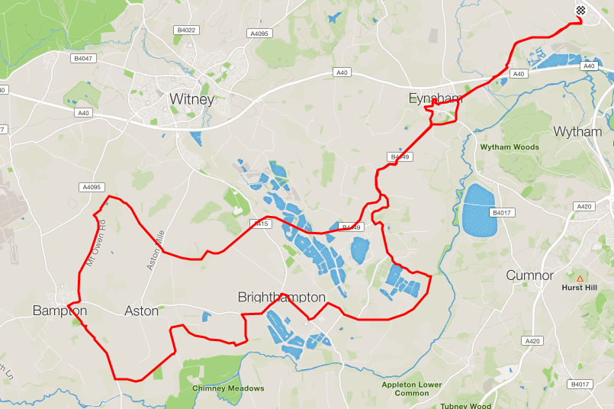

Basic directions
- Leave Yarnton along Cassington road, at A40 take old Cassington road
(mass start is usually the Back Lane car park)
- Leave Eynsham toward Stanton Harcourt either turn left into Sutton and out via New Road or continue on main road and turn left at roundabout.
Through Stanton Harcourt, and take left to Northmoor

Through Northmoor and onto Standlake.
At A415 junction turn Right along Abingdon Road, turn left at Brighthampton corner towards Aston, shortly take a left toward Shiford.
Before Cote take a left, then another left towards Chimney
At the river turn right and again at the junction at the end of this road.
Past Bampton Garden Centre over a bridge and turn right, Aston, at the edge of Bampton turn left and up and over Mount Owen.
At junction turn right, stay on this road across one road and through Yelford
Over the hill and down to traffic light, straight over and on towards Stanton Harcourt roundabout, Sutton and Eynsham

- At Fire station Roundabout take right along ring road until Old Cassington Road Roundabout and then reverse initial cycle back to Yarnton.

