Cycle route – 24 miles – start Yarnton – Eynsham start add 7 miles
Wendlebury Loop
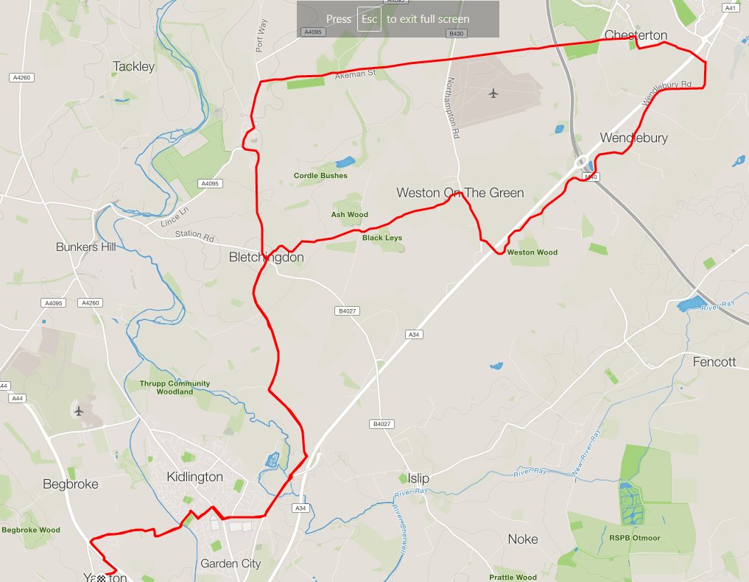

Basic directions
- Leave Yarnton along Sandy Lane/Yarnton Road, cross railway and canal.
At Junction turn right onto Oxford Road and later left at Bicester Road traffic lights (both ends of Bicester road
At roundabout keep left and then take left turn for Bletchingdon
At top of hill, at the cross roads, straight across and downhill into Weston on the Green
- At main Road turn right, left at roundabout, and right after crossing the A34 bridge toward Wendlebury. (Shorter Option Below)
Go through Wendlebury and just before the Bicester Garden Centre turn left towards Chesterton.
In Chesterton turn left by pub and along the straight back over the M40.
c- At cross road go straight across towards the Polo Grounds
End of the road turn left into Kirtlington.
Follow road through Kirtlington, just before you leave the village turn left back towards Bletchingdon.
Once in Bletchingdon, then turn left then right, to return back along the first part of the route.

Option
In Weston, to omit the Wendlebury loop, turn left not right and cycle past the airport and turn left onto the Kirtlington road at point C – reduces distance by 5 miles.

