Cycle route – 24 miles – start Yarnton – Eynsham start add 1 mile

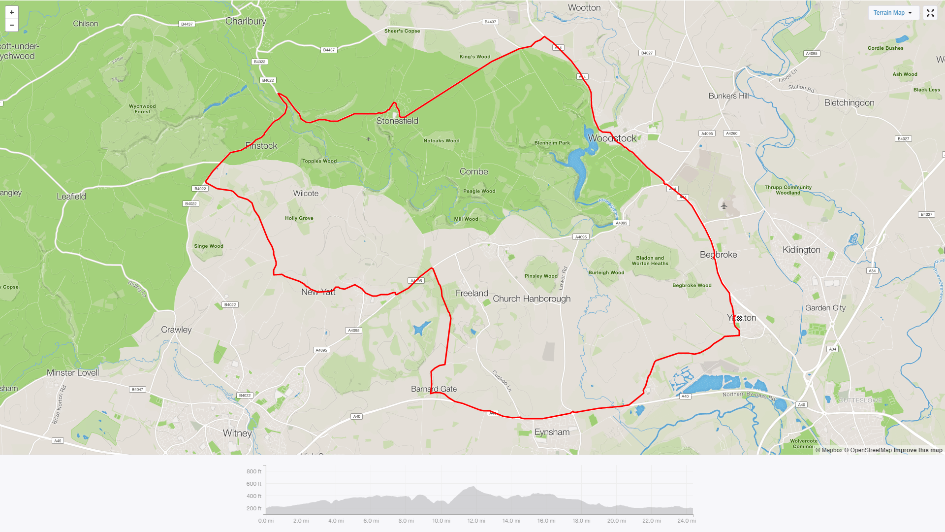

Basic directions
- Leave Yarnton along A44, into and through Woodstock on A44
After Woodstock Turn Left by Pub toward Stonesfield/Charlbury
Turn Left towards Stonesfield, along straight; into and exit village
At junction, green triangle, turn left towards Fawler
Through to the Charlbury - Finstock road.
Turn left and up long hill past Finstock onto Mount Skippy!!
- Over the top of the hill and down, turn left into Ramsden by Garden Centre Main entrance
Through Ramsden, along then left towards New Yatt and North Leigh.
At new Yatt junction turn left towards and through North Leigh
At main road turn left, towards Long Hanborough, then turn right into Cuckoo Lane.
Carry on Cuckoo lane until reach Bernard’s gate, left onto the A40 cycle track, along A40 to Cassington, left Into Cassington and back through to Yarnton

