Cycle route – 24 miles – start Yarnton – Eynsham start add 7 miles
Otmoor Loop
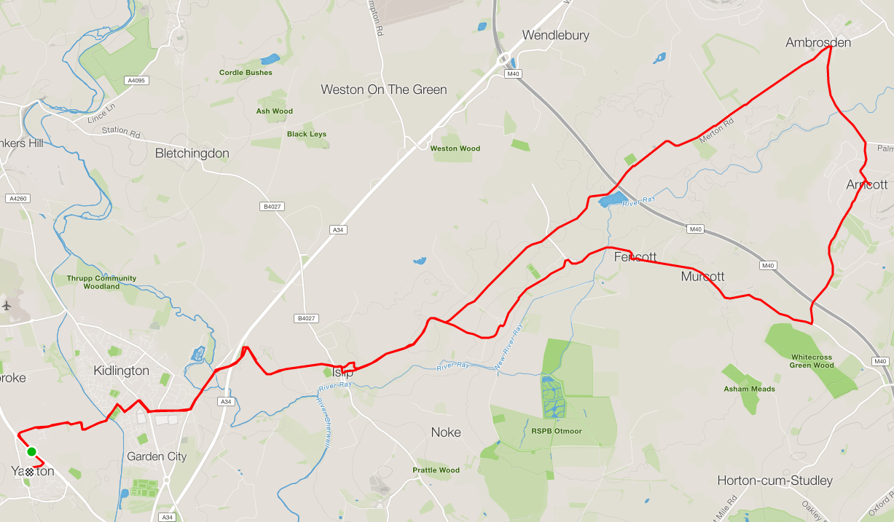

Basic directions
- Leave Yarnton along Sandy Lane/Yarnton Road, cross railway and canal.
At Junction turn right onto Oxford Road and left at Bicester Road traffic light (both ends of Bicester Road)
At roundabout take the right and take left turn for Islip
.
- At Islip T junction, turn right at the junction, around the two corners then left toward Charlton on Otmoor.
Down and out of Islip, take first or second right into Oddington and then on into Charlton On Otmoor.
At Junction take right towards and through Fencott and Murcott
After Murcott turn left, up and over M40 towards Arncott.
Follow road through Arncott to Ambrosden
Turn left into Merton Road, along the straight and through Merton and onto Islip

- Return to Yarnton using reverse rout at start of ride.

