Cycle route – 29 miles – start Yarnton – Eynsham start add upto 7 miles

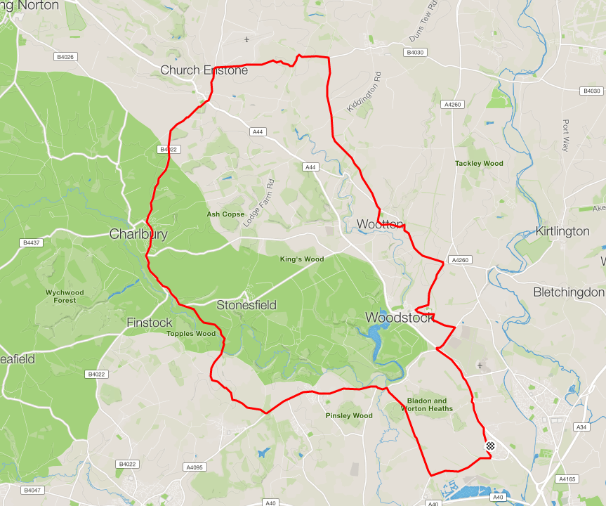

Basic directions
- Leave Yarnton on A44’s cycle track, at Bladon Roundabout take the third turn towards Bunker’s Hill, shortly turn left towards Marlborough School.
At mini roundabout turn right turn right onto Banbury Road and later left at Junction towards Wotton
- After Short Steep Downhill turn left onto narrow lane up and into Wotton
At the junction turn right to leave Wootton. At junction turn left
(if you miss this lane turning you end up here anyway)
After a few hundred yard/meters take right fork in road, towards Enstone, Tew Lane
At main road, after you’ve past Renault FI turn left, then later left again for Enstone.
Downhill and uphill to A44 junction, straight over towards Charlbury
- In Charlbury after initial short hill climb turn left, down the big hill and up, at the sharp corner take the right fork towards Finstock
Shortly take the first left toward Stonesfield
Go through Fawler but take right fork on leaving the village towards North Leigh/West End At the bridge turn right, downhill and back to the Long Hanborough to Witney Road.
Turn Left, down into and through Long Hanborough, turn right into Burley Road towards Cossington, then left on Cossington Road back to Yarnton

Option
Route can be joined at/left at Cuckoo lane if coming from Eynsham and tweaked as needed.

