Cycle route – 38 miles – start Yarnton – Eynsham start less 7 miles
Clanfiled Loop

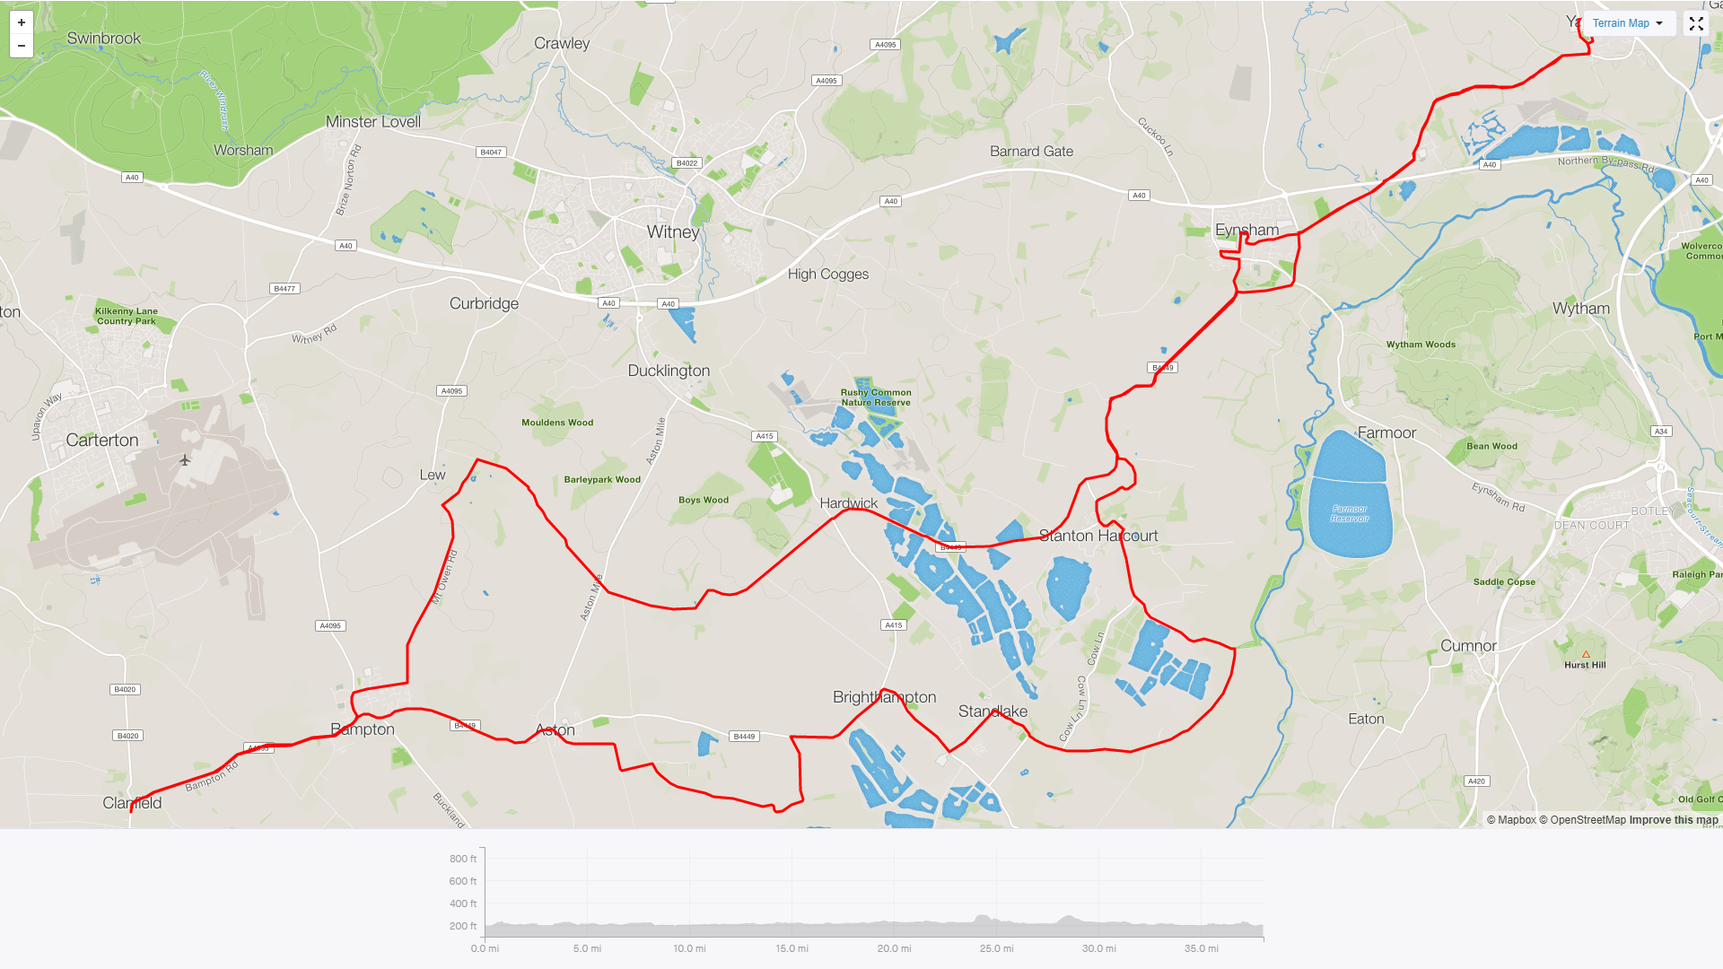

Basic directions
- Leave Yarnton along Cassington road, at A40 take Old Cassington Road
(mass start is usually the Back Lane car park)
- Leave Eynsham toward Stanton Harcourt either turn left into Sutton and out via New Road or continue on main road and turn left at roundabout.
Through Stanton Harcourt, and take left to Northmoor
Through Northmoor and onto Standlake.
At A415 junction turn Right along Abingdon Road, turn left at Brighthampton corner towards Aston, shortly take a left toward Shiford then on towards Cote
Turn left in Cote then right into Aston, through Aston into Bampton. Turn right at T junction and then left at mini roundabout towards Clanfield.

Normally stop at cafe here then reverse route to Bampton

At the mini roundabout in Bampton go left into Broad St then turn right into New Road.
At the end turn left and up and over Mount Owen.
At junction turn right, stay on this road across one road and through Yelford
Over the hill and down to traffic lights, straight over and on towards Stanton Harcourt roundabout, Sutton and Eynsham

- At Fire station Roundabout take right along ring road until Old Cassington Road Roundabout and then reverse initial cycle back to Yarnton.

