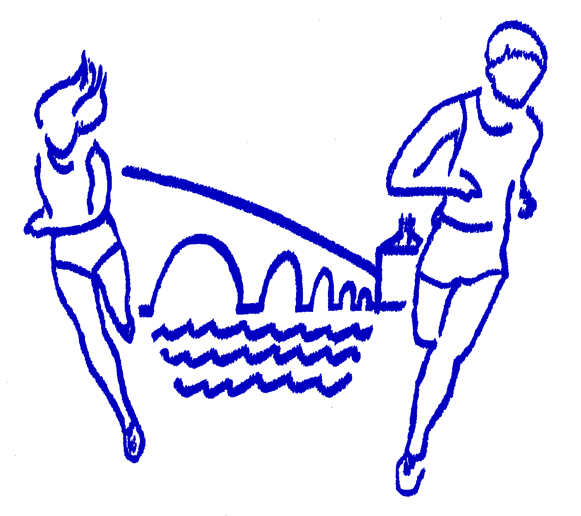
EYNSHAM ROADRUNNERS PRESENTS
EYNSHAM ROADRUNNERS

RUNNING SINCE 1986

www.polartechnology.co.uk
The 28th Polar Group Eynsham 10K
incorporating the final Oxon Grand Prix Event

and 1 mile Fun Run

Sunday 29th November 2015
10.30am at Bartholomew School, Eynsham, Oxford. OX29 4AP
UK Athletics Licence 2015-13811

Eynsham Roadrunners are delighted to welcome a new main sponsor for our 10k. Polar Technology Management Group are an advanced engineering group of companies based here in Eynsham

Race Information

On arrival: 10K runners please collect your number and timing chip from race HQ. You will have been notified of your number in advance of the race – please make sure you have this with you to reduce delays on the day.

Changing and Toilets
There are changing, shower and toilet facilities in Bartholomew School and the adjacent Leisure Centre. Kit bags etc. should not be left in the changing rooms, but may be left at the race HQ baggage counter at your own risk. Please use the toilets at race HQ. Do not urinate on verges and hedges in the residential area at the start.

Refreshments
Water will be available at 5K, with water and squash available at the finish. Hot and cold drinks and snacks will be on sale at the race HQ.

Timetable
09.00 Race HQ and changing facilities open
10.15 All runners make their way to start (NB. 10 minute walk to the start)
10.30 10K race starts
10.35 Fun Run starts
12.00 Presentation in School Hall

Prize Categories

10K Race |  | 1 Mile Fun Run
Race Winner | First Lady | First Boy U/15
First 3 Senior Men | First 3 Senior Ladies | First Girl U/15
First 3 Vet 40 Men | First 3 Vet 35 Ladies | Spot Prizes
First 2 Vet 50 Men | First 2 Vet 45 Ladies
First Vet 60 Man | First Vet 55 Lady
First Man and Woman Eynsham Resident
£100 bonus for new course record –Mens and Ladies
£100 for 1st Sub 30mins Man and 1st Sub 34mins Lady

Results can be found at www.eynshamroadrunners.org.uk
Important information
- If you suffer from a medical condition, please write this on the reverse side of your number.
- Please pin your number to the FRONT of your running vest.
- For safety reasons, ear pieces and headphones are not permitted and participants found abusing this rule will be disqualified.
- If you have an URGENT enquiry, please telephone 01865 881492.
- There will be no refund of entry fees if the race is cancelled at short notice by the police or referee. Please check our website www.eynshamroadrunners.org.uk for up to date information on weather and course conditions.
- General race enquiries, please email eynshamroadrunners10K@gmail.com

The course
The course has been accurately measured, is flat and comprises just over two laps on road and tarmac paths around Eynsham Village. The start is in Old Witney Road, with the finish in Bartholomew School through the Witney Road entrance. Please keep to the left hand side of the road at all times except when directed otherwise by the marshals. Please cross the roads only at the official crossing points (see map). Please abide by the directions of the marshals at all times. Drinks station at 5K. Not suitable for wheelchairs or pushchairs. No dogs.

Parking
Eynsham is situated on the South side of the A40, 6 miles West of Oxford. There are several free car parks (see map). Please use these car parks and avoid parking on the road. Main car park at OX29 4TW.

Fun Run information
Forms may be downloaded from our website www.eynshamroadrunners.org.uk and runners will be sent their number through the post in advance of race day. Entries will be available on the day, up to a maximum of 100 entrants.

